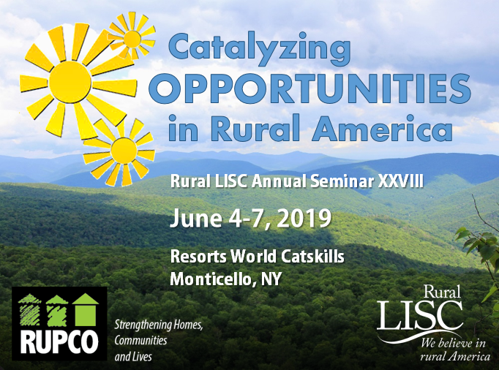
Frequently Asked Questions

________________________________________________________________

- How do I register for the Seminar?
Here is the link for registration: 2019 Rural LISC Annual Seminar.
Please complete one registration form per attendee. Most people will register on the “Seminar Registration Form.” On the form, please check all options that apply, such as Advisory Committee Member, speaker, sponsor, etc.
If you are a 3rd or 4th attendee from the same organization, or if you are want to register a guest who will join you for meals, use “Seminar Registration Form – Paying for Meals.”
If your plans change and you need to make a substitution? Here is the link to the instructions: https://www.eventbrite.com/support/articles/en_US/How_To/how-to-update-your-ticket-registration-information?lg=en_US. NOTE: The Eventbrite platform uses the term “ticket” instead of registration form.
Here is a link to the Seminar agenda on the Rural LISC Website: Agenda. You can check back periodically for an up-to-date Agenda with all of the latest information.
- How do I get to the Seminar?
Flying to New York:
- LaGuardia/JFK/Newark (all major airlines) – approximately 2 hours by car to hotel
- Albany (all major airlines) – 1.5-2 hours by car to hotel
- Stewart International (Newburgh, NY) – 45 minutes by car to hotel
With several options for traveling to New York, we recommend that you call Scott Ray at Universal Travel (717-442-3611) or e-mail sray@comcast.net to make your flight reservations; he can work with you to find the best option, and Universal Travel has arranged discounts off the lowest fares that will save you money.

Driving directions:
FROM NEW YORK CITY:
I-87 North to Exit 16 (Harriman) to Route 17 West
Take Exit 106
Go Straight Through Blinking Red Light
Proceed Straight Through Traffic Light
Follow Signs for Resorts World Catskills

FROM CONNECTICUT:
I-84 West to Exit 4W for Route 17 West
Take Exit 106
Go Straight Through Blinking Red Light
Proceed Straight Through Traffic Light
Follow Signs for Resorts World Catskills

FROM SCRANTON:
I-84 East to Exit 34 for PA-739 N
Get On NY-17E from PA- 434N
Follow NY 17E to Exit 106
Go Completely Around the Traffic Circle and Over the Bridge
Take a Left at the Traffic Light and Follow Signs for Resorts World Catskills

FROM ALBANY:
I-87 South to Exit 17 for I-84 West
Take Exit 4W for 17 West
Take Exit 106
Go Straight Through Blinking Red Light
Proceed Straight Through Traffic Light
Follow Signs for Resorts World Catskills

- Who should attend the Seminar?
Each Rural LISC organization should send the Executive Director/CEO/President and one board member.
- How are my travel expenses reimbursed?
● All Program and Network Partners can be reimbursed as Seminar-related costs are incurred, up to $3,500 (for two people).
● All Rural LISC Advisory Committee members may be reimbursed for expenses related to travel to and from the Seminar after returning home. Please send reimbursement requests with receipts to Rural LISC, ATTN: Murat Unal, 1825 K Street, NW, Suite 1100, Washington, DC 20006, or munal@lisc.org.

- Where is the Seminar taking place?
Resorts World Catskills – Site of all Seminar events
● $1.2 billion dollar destination resort with a waterpark (waterpark opening March,
2019); an 18-hole golf course opening early 2019.
● 2,200 employees when the casino/hotel/waterpark/golf course are complete.
● 332 Rooms, 2 pools, spa and fitness center.
● 100,000 square feet of gaming space.
● 10-plus restaurants including Cellaio, an Italian inspired steakhouse with a menu curated by the acclaimed chef Scott Conant; and the 24/7 Bistro that is always open.

- Where should I stay?
- Resorts World Catskills
888 Resorts World Drive, Monticello NY 12701
Phone Number for Reservations: 833-586-9358, ask for “2019 Rural LISC Annual Seminar.”
Website for Resorts World Catskills: click here.
Weblink to register online: Resorts World.

- The Alder Hotel at Resorts World Catskills
Guests of The Alder can enjoy all of the amenities at Resorts World Catskills. Reservations: same as Resorts World Catskills information above. We have an additional block of rooms reserved here.
● 101 guest rooms featuring 55-inch flat screen TVs, toiletries from Malin+Goetz, a coffee maker, safe, iHome clock with wireless charging station, irons and ironing boards, and high speed WiFi internet access.
● Topgolf Swing Suite and Dos Gatos, an upscale cantina-style eatery, are located next to The Alder lobby. Topgolf Swing Suite is a golf and entertainment simulator experience for players of all ages and skill levels.

- Another option, especially for families
The Kartrite Hotel & Indoor Waterpark (opening in March), located 10 minutes away from Resorts World Catskills. Rural LISC does not have rooms reserved here.
● Website: click here.
● The hotel will feature 324 all-suite rooms, and the indoor waterpark will be the largest in New York — stretched over two acres with 15 water slides and coasters, a wave pool, lazy river and indoor beach.

See you soon!

