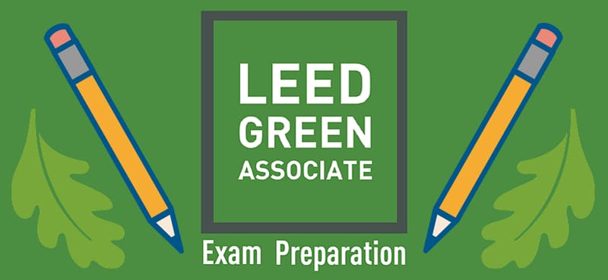
LEED Green Associate Application Form

Please email completed form to Emily Jones at ejones@lisc.org (copying your supervisor) by October 15, 2018.
Applicants will receive seat confirmation within one week of submission.
Please email or call (617.410.4336) with questions.
Applicant Name
Applicant Phone
Applicant Email
Organization Name
Organization Address
Organization Type (e.g. nonprofit, government, etc.)

Please check all boxes and sign below:
I am available to attend this daylong, no-cost LEED Green Associate Exam Preparation Class on Thursday, October 18, 2018 from 8:30AM to 5:00PM (at Castle Square Tenants Organization, 476 Tremont Street, Boston, MA 02116).
I agree to buy the LEED Green Associate Study Guide ($155) to prepare for the LEED Green Associate Exam (or my organization agrees to buy it for my study use).
I agree to take the LEED Green Associate Exam within 6 months of completion of this Exam Preparation Class.

Applicant’s Signature: __________________________________________________________ Date: _______________

(Please have supervisor fill out section below. If your organization is unable to pay for your exam fee, you are still eligible for this free LEED Green Associate Training if you pledge to take exam on your own.)

Applicant’s Supervisor Section:

Please check box and sign below:
My organization agrees to pay for the LEED Green Associate Study Guide ($155) for applicant to borrow to study.
My organization agrees to pay for the applicant’s LEED Green Associate Exam fee ($250).

Supervisor’s Signature: _________________________________________________________ Date: _______________

